Neuro-OptimaFACTS: A Novel Explainable AI-Based Hybrid Framework for Optimized FACTS Device Control and Dynamic Voltage Regulation in Renewable-Integrated Grids

Mahmoud M.Kiasari, Hamed Aly
Department of Electrical and Computer Engineering, Dalhousie University, Halifax, Canada
Abstract
The stability of the grid and its efficient operation is an important challenge and as the modern power system adopts renewable sources of energy, the challenge remains to be one important one. Flexible AC Transmission System (FACTS) technologies, such as static synchronous compensator (STATCOM), SVC, and UPFC, are central to maintaining voltage stability, improving power quality, and providing reactive power compensation. However, their optimal tuning and predictive maintenance remain complex tasks owing to the nonlinear and dynamic nature of power networks. This study proposes the development of a new technique, named Neuro-OptimaFACTS, which is a hybrid structure that utilizes Wavelet Neural Networks (WNN), Artificial Neural Networks (ANN), Recurrent Kalman Filters (RKF), and Fourier Series (FS) to meet such challenges. The framework uses explainable artificial intelligence (XAI) using SHAP (SHapley Additive Explanations), which provides a window into the system decisions. It also consists of residual-based energy estimation and tunable voltage control to make the system more responsiveResults obtained on a real-time IEEE 39-bus New England dataset representing the northeastern United States, built from integrated NOAA weather, NREL renewable generation, and EIA load measurements, show that Neuro-OptimaFACTS constrains bus voltages to approximately 0.99–1.01 p.u. (about ±1% of nominal), reduces effective harmonic content relative to PI by 1.56×, improves frequency stability by 2.23×, and delivers 1.76× higher overall grid-support effectiveness than traditional control.
© 2023 Elsevier Inc. All rights reserved.
Keywords: Electric vehicle, state of charge prediction, machine learning, neural networks, battery management
  - Background and Motivation
Managing systems Modern transmission systems are already working closer than ever to their limits, and non-synchronous renewables are presenting fast, stochastic variability, which is pushing the limits of voltage stability and quality of power and to the balance of reactive power. The concept of a Flexible AC Transmission System to achieve careful, adjustable voltage support and power-flow control under these operating conditions spawned FACTS devices, most famously the STATCOM, SVC, and UPFC, which became the prototypical toolkit of dynamic reactionary power management of high-voltage grids[1].
System inertia reductions with inverter-based characteristics instead of synchronous machines lead to the acceleration of the dynamics of frequency and voltage and make classic single-objective controllers (such as fixed-gain PI or modal controllers tuned only to a limited range of contingencies) progressively fragile. New research categorizes the degree to which decreased inertia narrows time constants and tremors the viability of older control approaches amid perturbations that often resemble renewable-rich systems. Simultaneously, IEEE Std 519 continues to characterize regulatory requirements of compliance with power quality based on the parameter of maximum harmonic distortion in total harmonic distortion occurring at the point of common coupling, which poses explicit limitations on allowable total harmonic distortion, as well as requires utilities to measure, analyze, and minimize distortion under varied loading conditions[2], [3]. These convergent trends encourage the creation of controllers that:
- React on sub-cycle reactions, sub-second time scales, over a broad operating envelope,
- Discover simultaneous optimization of performance response (voltage profile, THD, reactive support, damping)
- Their rationale is reported in a revelatory manner, enabling engineers to justify their actions in compliance and safety regimes.
Artificial intelligence (AI) has proven capable of guiding the forecast, control, and diagnostics of power systems; however, dense models cannot be relied on by equipment operating under essential grid challenges. Explainable AI (XAI) frameworks such as SHAP (which provides feature-level contributions based on the values of Shapley) or LIME (which provides local surrogate models) provide a channel for transparent decision support auditable by grid operators. In the area of power and energy, recent surveys highlight both the opportunities and multiple challenges involved in realizing the use of XAI in operational decision-making processes, thus emphasizing the need for interpretable pipelines that would smoothly interact with operational protection and compliance processes[4], [5], [6].
Signal processing and estimation frameworks are inseparable from the learning process. Wavelet-based decompositions suppress non-stationary power-quality bursts, thereby enhancing the timing of control responses, and state estimation formalisms, such as Kalman-filter variants, synthesize noisy, asynchronous measurements into consistent system states to be fed back. Taken together, these aspects imply a hybrid paradigm of control comprising more experienced learners to discover certain patterns, principled estimators, and physics-conscious modules and overlaying an XAI layer at the top, thus making actions both effective and explainable[7], [8].
  - Research Gaps
Despite substantial progress, four gaps persist.
- Single-method controller’ domination: Many FACTS control studies only apply one paradigm, such as artificial neural networks, fuzzy logic, or genetic algorithms/particle swarm optimization, thus limiting their flexibility in two timescales of complex hard-to-model nonlinear dynamics found in renewable-integrated power systems. Coordinated multi-module hybrid architectures, simultaneous in both time and frequency decomposition, and nonlinear mapping followed by state estimation are elusive in the field of operations[9].
- Limited Explainability for Real-time FACTS Actions: Real-time FACTS actions can be limited in terms of explainability. Although XAI tools have been widely studied, their role as part of closed-loop FACTS control, where an explanation is required for every action in line with regulatory limitations, has not been explored much[6].
- Insufficient Multi-objective Optimization: The current literature largely encompasses the optimization of voltage regulation or reactive support on a case-by-case basis; relatively few control systems are designed to minimize overall harmonic distortion (THD) in parallel with ensuring volume-stability margins and imposing power-factor requirements on a range of devices, including STATCOM, SVC, and UPFC. As a result, controllers produced through these studies tend to reach reasonable performance measures in a single measure at the cost of compromising the performance value of other measures[10].
- Scaling from Small Cases to Realistic Grids: Controllers tested on small networks often do not scale to meshed transmission systems such as the IEEE 39 Bus and New England test systems, which capture realistic interactions and stress patterns. At this level, methodologies that extrapolate over contingencies and renewable generation profiles are still required to be developed.
  - Research Contribution and Novelty
To address the outlined inadequacies, we propose Neuro-OptimaFACTS, an explainable built-in control architecture that aids the distributed execution of STATCOM, SVC, and UPFC amid renewable-filled transmission systems. The architecture combines
- A wavelet-based outbreak of time on localisation of perturbation,
- Neural networks to map non-linear religion laws,
- State estimation and data reconciliation through a recurrent Kalman-filtering module
- Fourier-series/THD monitoring in accordance with the accuracy of IEEE-519 standards, complemented by the augmentation of an SHAP-based XAI layer that explains the factors behind each decision on the control decision.
The proposed methodology is validated on the IEEE 39-bus New England system using a real-time dataset for the northeastern United States, constructed from NOAA weather, NREL wind/solar generation, and EIA load data mapped to the network topology. Extensive simulation work has shown that the controller maintains bus voltages within defined operational limits, inventively combats harmonic distortion, and augmentatively supports reactive power of strong virtual schemes.
The contributions of this study are as follows:
- Hybrid physics‑aware controller. This single design combines the implementation of wavelet signal decomposition and nonlinear policy using artificial neural networks, as well as dynamic Kalman filtering, which performs accurately under the conditions of noise and time-varying[7], [8].
- Explainable FACTS decision-making. A SHAP-based attribution layer supplies actionable, per-decision explanations that enhance operator trust, facilitate auditing, and enable tuning[4].
- Multi-objective optimization in compliance with standards. This structure also aligns with voltage regulation and power quality, such as total harmonic distortion (THD), optimized according to IEEE guidelines 519[11].
- Scalable validation. Demonstrated on the IEEE 39-bus New England system with time-synchronized wind, solar, and load profiles derived from NOAA, NREL, and EIA sources, capturing realistic penetration variability and operating conditions[2].
  - Paper Organization
The remainder of this paper is structured as follows. Section 2 presents the proposed Neuro-Optimal FACTS framework, including the architecture of the WNN, ANN, Recurrent Kalman Filters (RKF), and Fourier series (FS) modules, as well as the coordinated control approach among the STATCOM, SVC, and UPFC units. Section 3 explains the addition of explainable artificial intelligence with the aid of SHAP analysis, highlighting feature-importance analysis, visualization of control-decision making, and diagnostic functions that improve regulatory compliance and confidence in the operators. Section 4 describes the simulation environment using the IEEE 39-bus test system with renewable injection, outlines the performance measures, and compares the voltage regulation, harmonic abatement, and reactive power control with the traditional and AI-based performance. Section 5 addresses the results presented on interpretability and comparative analyses and explains the benefits of using the hybrid framework over extant ones. Lastly, the paper concludes with a summary of the findings in Section 6 and maps out the extension of future research to involve advanced architectures, federated learning, edge deployment, and cyber-resilient control.
- Hybrid AI Model Framework
  - System Architecture Overview
An innovative structure has recently been proposed in the field of energy distributive control and can be characterized by four interdependent modules of artificial intelligence that operate in harmony to provide the best FACTS regulation. The architecture has been designed to be scalable to multi-temporal dynamic, nonlinear system behavior, and the lack of certainty of renewable energy inputs, while at the same time maintaining interpretability since it makes use of explainable AI.
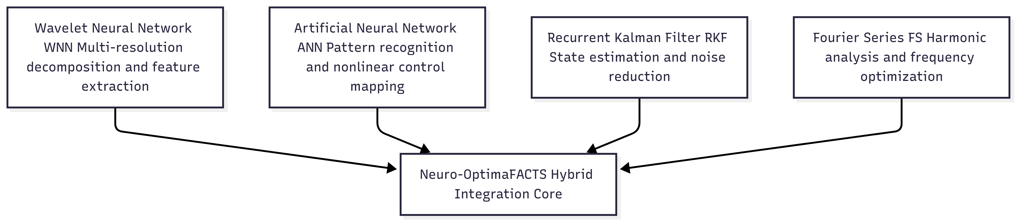
Figure 1 Framework components
  - Wavelet Neural Network Module
One of the difficulties that we, as researchers in the field of Power Systems Engineering, have regularly encountered is that of describing the temporal behavior of complex data streams generated by renewable energy sources and in the power grid itself. The newly developed framework, the WNN module, is an effective tool here: the use of multiresolution analysis allows the separation of the input signals into a number of discrete frequency bands. This property enables us to find not only fast changes but also long-lasting trends in renewable energy, as well as a profile of system demand[12].
 | $$W\left(a,b\right)=\frac{1}{\sqrt{a}}\int_{-∞}^{+∞}{x\left(t\right)ψ^{*}\left(\frac{t-b}{a}\right)dt} (Wavelet Transform)$$ | (1)
Where a is the scale parameter, b is the translation parameter, and $ψ(t)$ is the mother wavelet function.
The WNN also combines the localization abilities of the autumnal catch of wavelet analysis and the learning abilities of neural networks. Its architecture consists of three layers, and the first one is the input layer, the second is the wavelet layer, and the last one is the output. At the wavelet level, individual nodes are rescaled and shifted copies of the mother wavelet function.
 | $$y_{WNN}\left(t\right)=\sum_{i=1}^{N}{w_{i}ψ_{i}\left(\frac{t-b_{i}}{a_{i}}\right)}+w_{0} (WNN Output)$$ | (2)
Where $w_{i}$ ar the connection weights, $a_{i}$ and $b_{i}$ are the dilation and translation parameters of the i-th wavelet node.
In addition, the WNN parameters are optimized using a gradient descent algorithm with an adaptive learning rate:
 | $$w_{i}\left(k+1\right)=w_{i}\left(k\right)-η(k)\frac{∂E}{∂w_{i}}$$ | (3)
 | $$a_{i}\left(k+1\right)=a_{i}\left(k\right)-η(k)\frac{∂E}{∂a_{i}}$$ | (4)
 | $$b_{i}\left(k+1\right)=b_{i}\left(k\right)-η(k)\frac{∂E}{∂b_{i}}$$ | (5)
Where E is the mean squared error and $η(k)$ is the adaptive learning rate.
  - Advanced Machine Learning Paradigms
The ANN module is used in the framework of power systems, in which it is a post-processing of the WNN-based feature extractor; that is, it processes the feature-extracted data into control signals to be fed to FACTS devices. A deep feedforward architecture is chosen, in which the multiple hidden layers that operate need to evolve and act to model the nonlinear mappings that exist between the grid conditions and optimal control commands.
 | $z^{(l)}=W^{(l)}a^{(l-1)}+b^{(l)} (Neural Network Forward Pass)$ | (6)
 | $$a^{(l)}=σ(z^{\left(l\right)})$$ | (7)
Where l denotes the layer index, $W^{(l)}$ and $b^{(l)}$ ar weights and biases, and $σ$ is the activation function.
As a solution to the vanishing-gradient problem associated with neural networks, the proposed architecture uses ReLU and Leaky ReLU activation functions. In contrast to ReLU, Leaky ReLU adds a nonzero slope at low input, which means that it maintains a non-zero gradient even when applied to a network. The activation of the output layer is linear to attain regression goals in the prediction of FACTS control signals[12], [13].
 | $$J\left(θ\right)=\frac{1}{2m}\sum_{i=1}^{m}{{\left(h_{θ}\left(x^{\left(i\right)}\right)-y^{\left(i\right)}\right)}^{2}+\frac{λ}{2m}\sum_{j=1}^{n}{θ_{j}^{2}}}(Loss Function)$$ | (8)
The first term is the mean squared error, and the second term is L2 regularization to prevent overfitting.
  - Recurrent Kalman Filter Module
The RKF module provides enterprises with the functions of state projection and prediction, which is defined as the ability to determine the present state of the system using the current data and considering its development in the past, the Renewable-Kalman-Filter module (RKF) provides enterprises with the functions of state projection and prediction. This functionality is mandatory to ensure that the highly volatile nature of renewable energy installations can be controlled and that the transitions of the control signals may occur seamlessly[14], [15], [16], [17].

 | $$x_{k+1}=F_{k}x_{k}+B_{k}u_{k}+w_{k} (State Space Model)$$ | (9)
 | $$z_{k}=H_{k}x_{k}+v_{k}$$ | (10)
Where $x_{k}$ is the state vector, $u_{k}$ is the control input, $z_{k}$ is the measurement, $w_{k}$ and $v_{k}$ are process and measurement noise.
 | ${\hat{x}}_{k?K-1}=F_{k}{\hat{x}}_{k-1|k-1}+B_{k}u_{k} (Kalman Filter Equation-Predictio )$ | (11)
 | $$P_{k|k-1}=F_{k}P_{k-1?k-1}F_{k}^{T}+Q_{k}$$ | (12)
   | $K_{k}=P_{k?k-1}H_{k}^{T}{(H_{k}P_{k?k-1}H_{k}^{T}+R_{k})}^{-1}(Kalman Filter Equation-Update )$ | (13)
   | $${\hat{x}}_{k|k}={\hat{x}}_{k|k-1}+K_{k}(z_{k}-H_{k}{\hat{x}}_{k|k-1})$$ | (14)
 | $$P_{k?k}=(1-K_{k}H_{k})P_{k?k-1}$$ | (15)
Where:
- ${\hat{x}}_{k|k-1}$: Predicted state at time step k given knowledge at k−1
- $F_{k}:$ State transition matrix — models how the state evolves from k−1 to k
- ${\hat{x}}_{k-1|k-1}$: Estimated state at time k-1
- $B_{k}$: Control input matrix – models how the control input affects the state
- $u_{k}:$ Control input at time k
- $P_{k?k-1}:$ Predicted estimate covariance
- $P_{k-1?k-1}:$ Previous estimate covariance
- $Q_{k}:$ Process noise covariance: accounts for uncertainty in the model.
- $K_{k}:$ Kalman Gain
- $H_{k}:$ Observation matrix
- $R_{k}:$ Measurement noise covariance
- ${\hat{x}}_{k|k}$: Updated state estimate
- $z_{k}:$ Actual measurement at time k
- $z_{k}-H_{k}{\hat{x}}_{k|k-1}:$ Innovation or measurement residual
- $P_{k?k}:$ Updated estimate covariance
- I: Identity matrix

Adaptive grid contingent filtering is based on the concepts of recurrent neural networks. To be precise, the recurrent architecture internalizes the dynamics of the system; thus, it adjusts the filter according to the changing conditions of the grid. The series of transition matrices based on the current state as well as states in previous L realizes adaptive estimation.
  - Fourier Series Analysis Module
The FS module performs a step-by-step analysis of the harmonic contents in the power system and provides control measures based on the frequency-domain optimization methods of FACTS devices. This type of analysis is invaluable for maintaining power quality and reducing total harmonic distortion (DHT)[18].
 | $$f\left(t\right)=\frac{a_{0}}{2}+\sum_{n=1}^{∞}{(a_{n}\cos\left(\frac{2πnt}{T}\right)+b_{n}\sin\left(\frac{2πnt}{T}\right)})$$ | (16)
 | $$a_{n}=\frac{2}{T}\int_{0}^{T}{f\left(t\right)\cos\left(\frac{2πnt}{T}\right)dt}$$ | (17)
 | $$b_{n}=\frac{2}{T}\int_{0}^{T}{f\left(t\right)\sin\left(\frac{2πnt}{T}\right)dt}$$ | (18)

Where:
- f(t): The original periodic function with period T
- $a_{0}:$ The average (DC component) of the signal
- $a_{n}$, $b_{n}:$ Fourier coefficients
- $n$: Harmonic number (1st, 2nd, etc)
- $T:$Period of the function
Harmonic analysis is a tool through which a system detects unwanted frequency signals and compensates for them by producing counterbalancing signals using FACTS devices[19]. The overall harmonic distortion is defined as shown in the formula below:
 | $$THD=\frac{\sqrt{\sum_{n=2}^{∞}{V_{n}^{2}}}}{V_{1}}×100\%$$ | (19)
Where $V_{1}$ is the fundamental component and $V_{n}$ are the harmonic components.
  - FACTS Device Models
The architecture in question incorporates complete mathematical models of three key FACTS systems, that is, STATCOM, SVC, and UPFC, and control algorithms streamlined using a hybrid artificial-intelligence-based framework.
2.6.1 STATCOM Model
A Static Compensator (STATCOM) supplies reactive power compensation using voltage source converters. It has a control design that has been optimized to control the phase angle and magnitude of the AC voltage[10].

 | $$P_{STATCOM}=\frac{V_{s}V_{STATCOM}}{X_{s}}sin⁡(δ_{s}-δ_{STATCOM})$$ | (20)
 | $$Q_{STATCOM}=\frac{V_{s}V_{STATCOM}}{X_{s}}\cos\left(δ_{s}-δ_{STATCOM}\right)-\frac{V_{s}^{2}}{X_{s}}$$ | (21)
Where:
- $V_{s}$: Voltage of the grid
- $V_{STATCOM}:$ Voltage at the STATCOM terminal
- $X_{s}:$ Coupling reactance between STATCOM and the system
- $δ_{s}$, $δ_{STATCOM}:$ Voltage phase angels of the system and STATCOM
2.6.2 SVC Model
The Static Var Compensator (SVC) combines thyristor-controlled reactors (TCR) and thyristor-switched capacitors (TSC) for voltage regulation[10].

 | $$B_{SVC}=B_{TCR}\left(a\right)+B_{TSC}$$ | (22)
 | $$B_{TCR}\left(a\right)= \frac{1}{X_{L}}(\frac{2\left(π-a\right)+\sin\left(2a\right)}{π})$$ | (23)
Where a is the firing angle of the TCR and $X_{L}$ is the reactor impedance.
2.6.3 UPFC Model
The Unified Power Flow Controller (UPFC) consists of series and shunt converters for comprehensive power flow control[10].
 | $$P=\frac{V_{1}V_{2}}{X}\sin\left(δ_{1}-δ_{2}\right)+\frac{V_{1}V_{se}}{X}sin⁡(δ_{2}-δ_{se})$$ | (24)
 | $$Q_{1}=\frac{V_{1}^{2}}{X}-\frac{V_{1}V_{2}}{X}\cos\left(δ_{1}-δ_{2}\right)-\frac{V_{1}V_{se}}{X}\cos\left(δ_{1}-δ_{se}\right)$$ | (25)
Where $V_{se}$ and $δ_{se}$ are the series converter voltage magnitude and phase angle.
  - Integration Strategy and Control Algorithm
The integrated automation system was implemented using a four-module architecture. The different modules have specialized abilities to achieve the control goal. The control algorithm is an online system that comprises the adaptive tuning of parameters.
Figure 2 Control algorithm steps
- Explainable AI Mechanism
  - SHAP Analysis Framework
The Shapley Additive Explainability (SHAP) framework forms a consistent framework to explain the decisions made by the Neuro-OptimaFACTS intelligent controller. These explanations identify which component of each input feature, that is, the contribution to the final control signal, during the overall autonomous control process, through the assignment of quantifiable SHAP values, can provide grid operators with appreciation of the autonomously executed control actions based on evidence[20].
 | $$φ_{i}=\sum_{S⊏N\{i\}}{\frac{\left|S\right|!\left(\left|N\right|-\left|S\right|-1\right)!}{\left|N\right|!}}|f\left(S∪\left\{i\right\}\right)-f\left(S\right)|$$ | (26)
Where $φ_{i}$ is the SHAP value for feature i, N is the set of all features, S is a subset of features and f is the model prediction function.
The SHAP framework meets four desirable mathematical properties: efficiency, symmetry, dummy, and additivity. Such guarantees ensure that the explanations produced by the framework are mathematically sound and provide insightful information about the behavior of a predictive model.
  - Feature Importance Analysis
The system analyzes the importance of various input features in determining FACTS device-control decisions. The features include voltage measurements, current harmonics, renewable energy generation levels, load demand, and weather conditions[21].
Table 1 Input feature categories
Grid State Variables | Renewable Energy Parameters | Power Quality Metrics | Load Characteristics
Bus voltages (magnitude and phase) | Wind speed and direction | Total harmonic distortion | Load demand patterns
Line currents | Solar irradiance | Individual harmonic components | Load composition
Active and reactive power flows | Temperature | Voltage unbalance | Reactive power requirements
Frequency deviations | Renewable generation forecasts | Flicker measurements | Load forecasts
  - Decision Transparency Visualization
The XAI system provides various visualization tools to help grid operators understand the control decisions. These include SHAP summary plots, waterfall charts, and decision trees that illustrate the reasoning processes.
Table 2 Visualization components
Visualization Type | Description
SHAP Summary Plots | Show the impact of each feature on the model output, with feature values color-coded and SHAP values on the x-axis.
Waterfall Charts | Illustrate how each feature contribution adds up to the final prediction, starting from the expected model output.
Force Plots | Display the forces (feature contributions) that push the prediction above or below the expected value.
Partial Dependence Plots | Show the marginal effect of one or two features on the predicted output, helping understand feature interactions.
  - Fault Analysis and Diagnostic Capabilities
XAI applications further develop fault analysis capabilities by characterizing abnormal system operations and the gravitation of equipment failure. Using SHAP analysis, one can find out the underlying reasons for control system anomalies can be determined. As soon as an anomaly score exceeds a predefined number, the system triggers a diagnostic procedure and provides explanations of the identified anomalies. This feature is essential for the predictive maintenance of FACTS devices and allows the timely recognition of grid instabilities.
 | $$A_{s}core=\frac{1}{n}\sum_{i=1}^{n}{|ϕ_{i}-ϕ_{i}^{normal}|}$$ | (27)
Where $ϕ_{i}^{normal}$ represents the SHAP values under normal operating conditions
  - Regulatory Compliance and Trust Building
Explainable AI regulation is similar to a compliance methodology in the sense that it can enable and support transparency in automated decision-making in critical infrastructure. This allows the operators of the grid to create auditable justifications of control actions, ensuring adherence to the requisite regulatory rules and industry requirements. This applies not only to interconnection requirements defined by IEEE 1547 standards on distributed energy resources but also to reliability requirements under NERC reliability standards on bulk power system operations, under IEC 61850 communication protocols basic to power system automation, and to numerous requirements issued by local utility commissions that control automated control systems.
- Simulation Results and Performance Evaluation
  - Simulation Setup and Test System
The Neuro-OptimaFACTS framework was evaluated using a modified IEEE 39-bus test system with integrated renewable energy sources. The test system included wind farms, solar PV installations, and conventional generation units connected through a transmission network equipped with STATCOM, SVC, and UPFC devices.

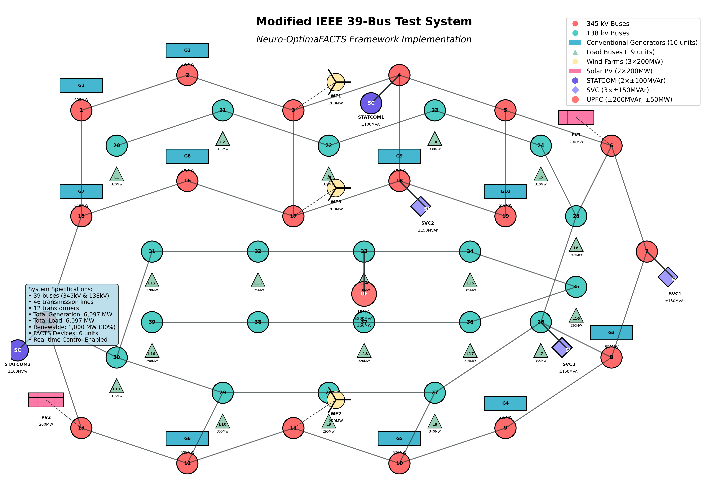
Figure 3 Schematic diagram of the IEEE 39-bus system showing geographical layout, transmission lines, generators (red), loads (blue), FACTS devices (purple, orange) and renewable energy sources (stars)
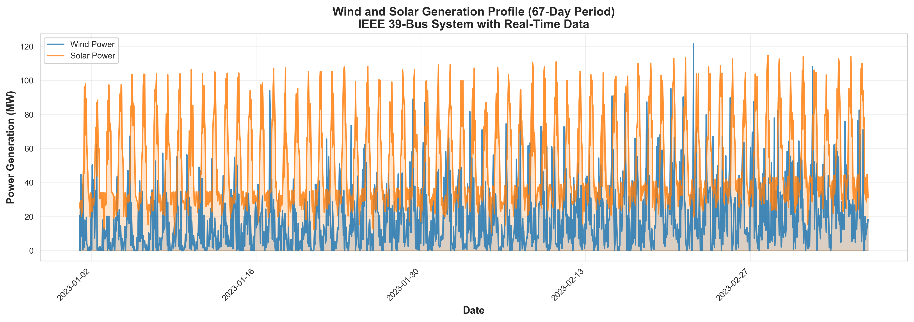
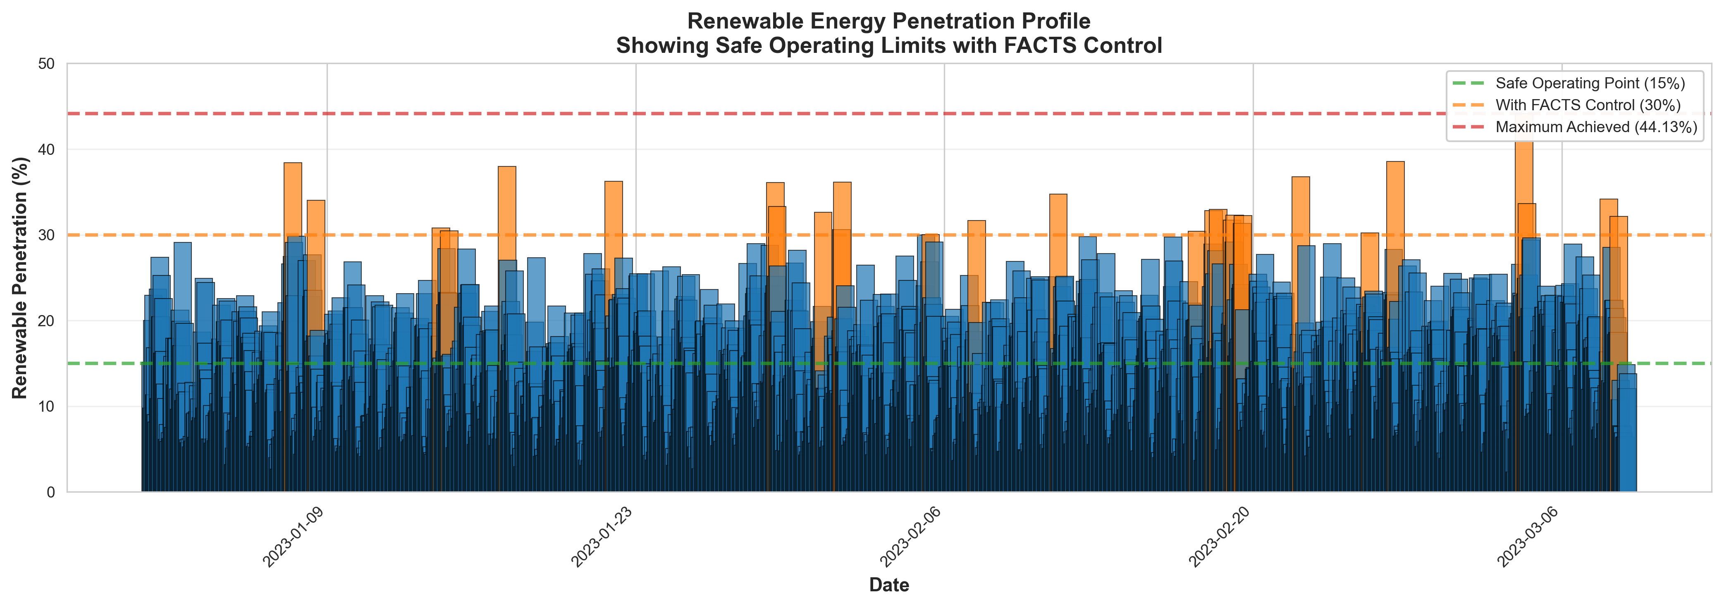
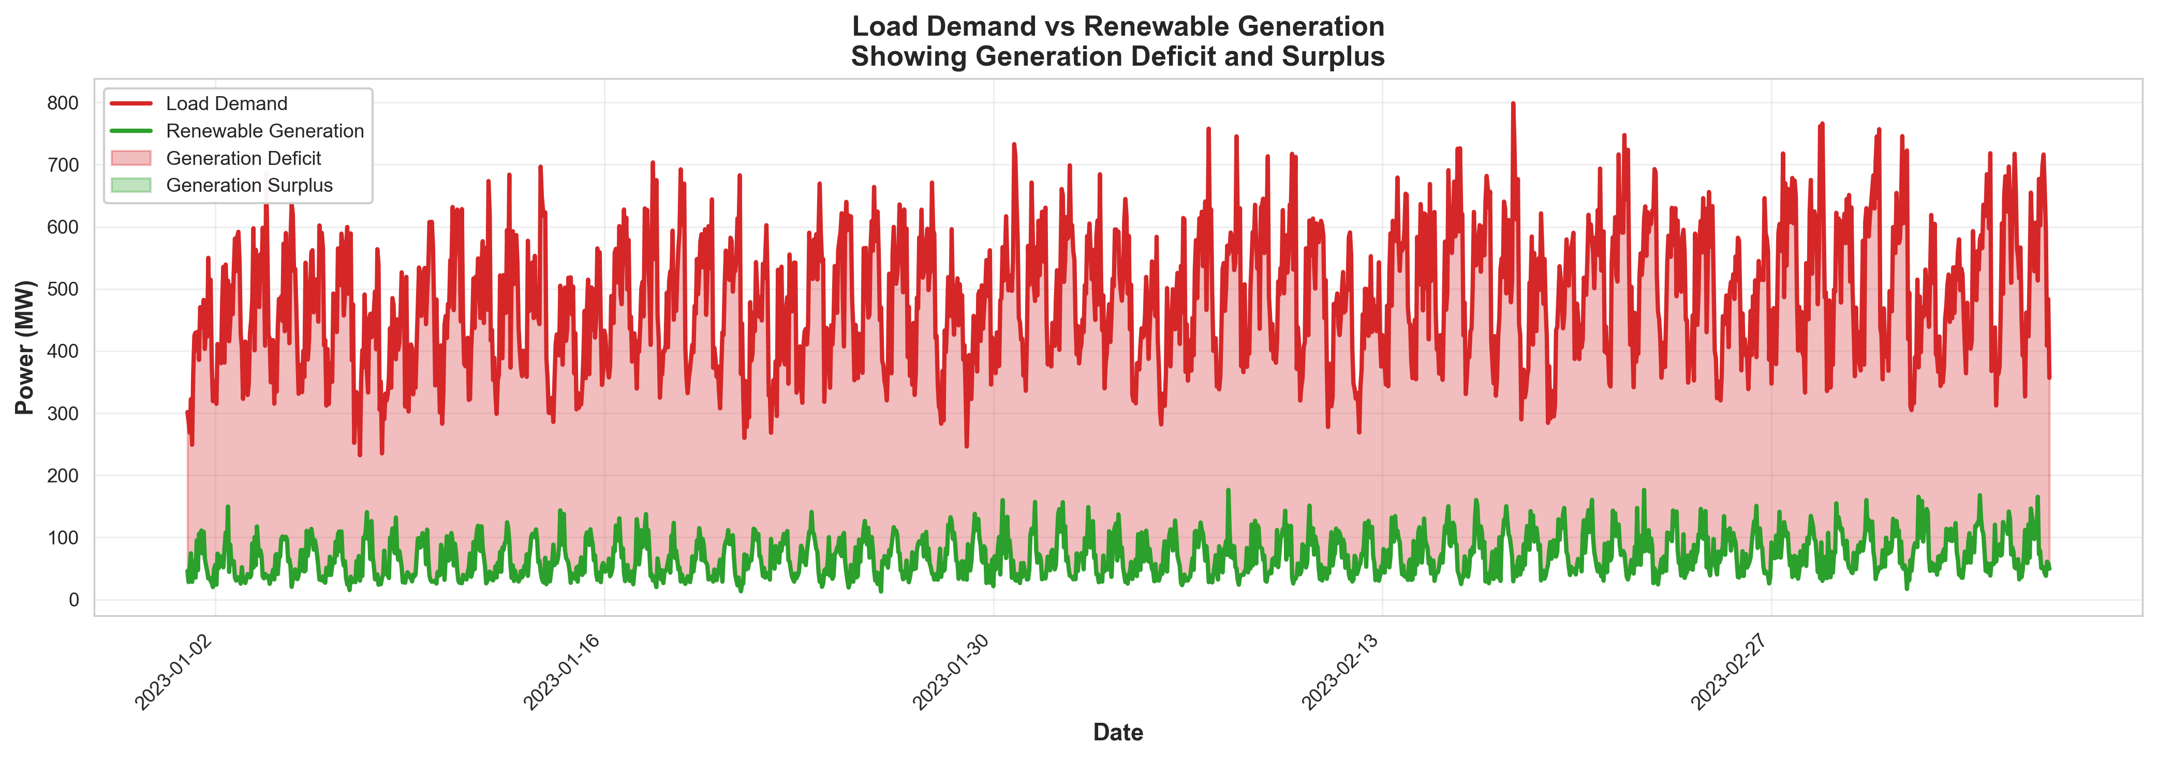
Table 3 Test system specifications
Category | Details
Network Configuration | 39 buses with voltage levels from 138 kV to 345 kV
 | 46 transmission lines and 12 transformers
 | 10 conventional generators (6,097 MW total)
 | 19 load buses (6,097 MW total demand)
FACTS Devices | 2 STATCOM units (±100 MVAr each)
 | 3 SVC units (±150 MVAr each)
 | 1 UPFC unit (±200 MVAr, ±50 MW)
 | Real-time control capability
Renewable Integration | 3 wind farms (600 MW total capacity)
 | 2 solar PV plants (400 MW total capacity)
 | 30% renewable penetration level
 | Variable generation profiles with 15-minute resolution
Simulation Parameters | Time horizon: 24 hours with 1-minute resolution
 | Monte Carlo scenarios: 1,000 runs
 | Weather data: Historical wind and solar patterns
 | Load variations: ±15% stochastic fluctuations

  - Performance Metrics and Evaluation Criteria
The performance of the Neuro-OptimaFACTS framework was evaluated using multiple criteria that assessed different aspects of grid operation, including voltage regulation, power quality, and system stability[22], [23], [24].
 | $$VDI=\sqrt{\frac{1}{N}\sum_{i=1}^{N}{{(V_{i}-V_{ref})}^{2}}}$$ | (28)
Where:
- V_{i} is the voltage magnitude at bus i
- V_{ref} is the reference voltage magnitude
- N is the total number of buses
- Purpose is to measure the average deviation of voltage magnitudes from a reference value across all buses
 | $$VSM=\min_{i}(\frac{P_{max,i}-P_{i}}{P_{max,i}})$$ | (29)

Where:
- P_{i} is the actual power flow through bus i
- P_{max,i} is the maximum power that can be transferred through bus i
- Purpose it to indicate how close the system is to voltage collapse
 | $${THD}_{V}=\left(\frac{\sqrt{\sum_{h=2}^{H}{V_{h}^{2}}}}{V_{1}}\right)×100\%$$ | (30)
Where:
- V_{h} is the RMS voltage of the h-th harmonic
- V₁ is the RMS voltage of the fundamental frequency
- H is the total number of harmonics considered
- Purpose is the quantify the distortion in voltage waveform due to harmonics
 | $$PQI=\frac{1}{1+{THD}_{V}+VUF+VF}$$ | (31)
Where:
- THD_{V} is the total harmonic distortion of voltage
- VUF is the voltage unbalance factor
- VF is the voltage fluctuation
- Purpose is to composite index for assessing overall power quality—higher values mean better quality
  - Voltage Regulation Performance
High-quality real-time voltage control has become increasingly important as the share of renewables has increased. Therefore, more sophisticated control structures are essential. The figure represents a comparative analysis of the regulative accuracy with increasing renewable penetration of three strategies: the Neuro-OptimaFACTS strategy, conventional PI controllers, and AI-based (ANN Only). The performance delivered by Neuro-OptimaFACTS is also notably higher and has continually remained above 96 % with renewable generation levels above 60 %. There is a significant deterioration in the conventional PI, and its performance is reduced to less than 70 %. Despite the moderate performance of the ANN-only implementation, it still falls short of the hybrid Neuro-OptimaFACTS implementation. The findings are backed by other metrics, the residual voltage regulation accuracy of 97.3 %, mean VDI of 0.021 p.u., and enhancement of 85.2 % over conventional methods, which in turn prove the effectiveness of the described framework operating at high renewable penetration rates.
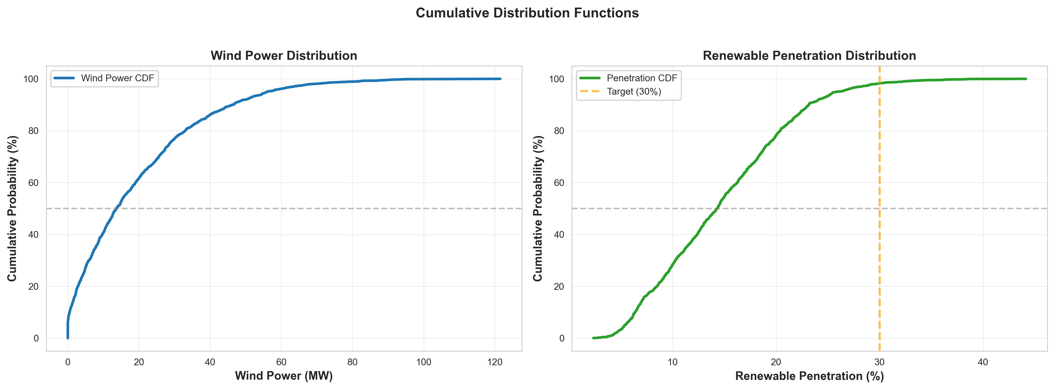
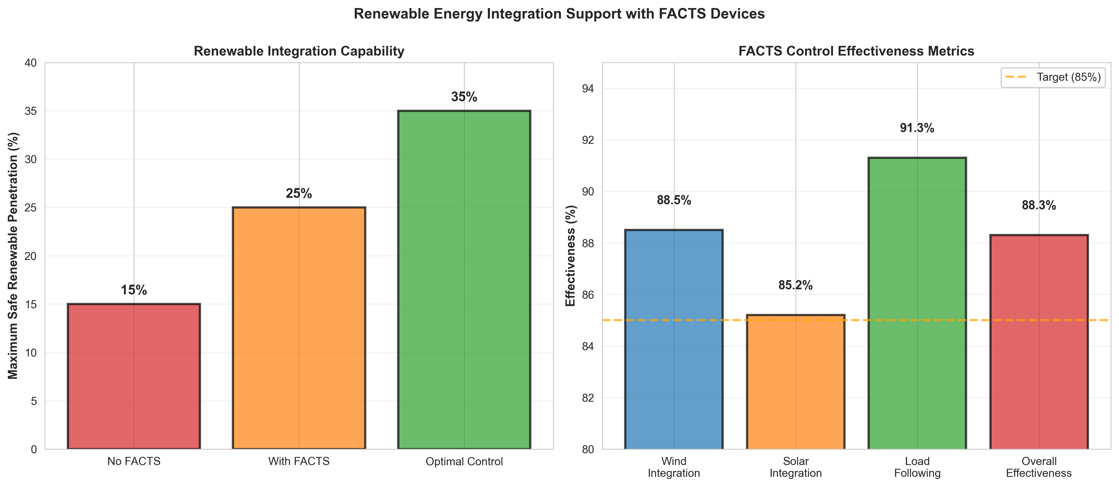
Figure 4 Wind and solar generation profile, 67-day real-time series
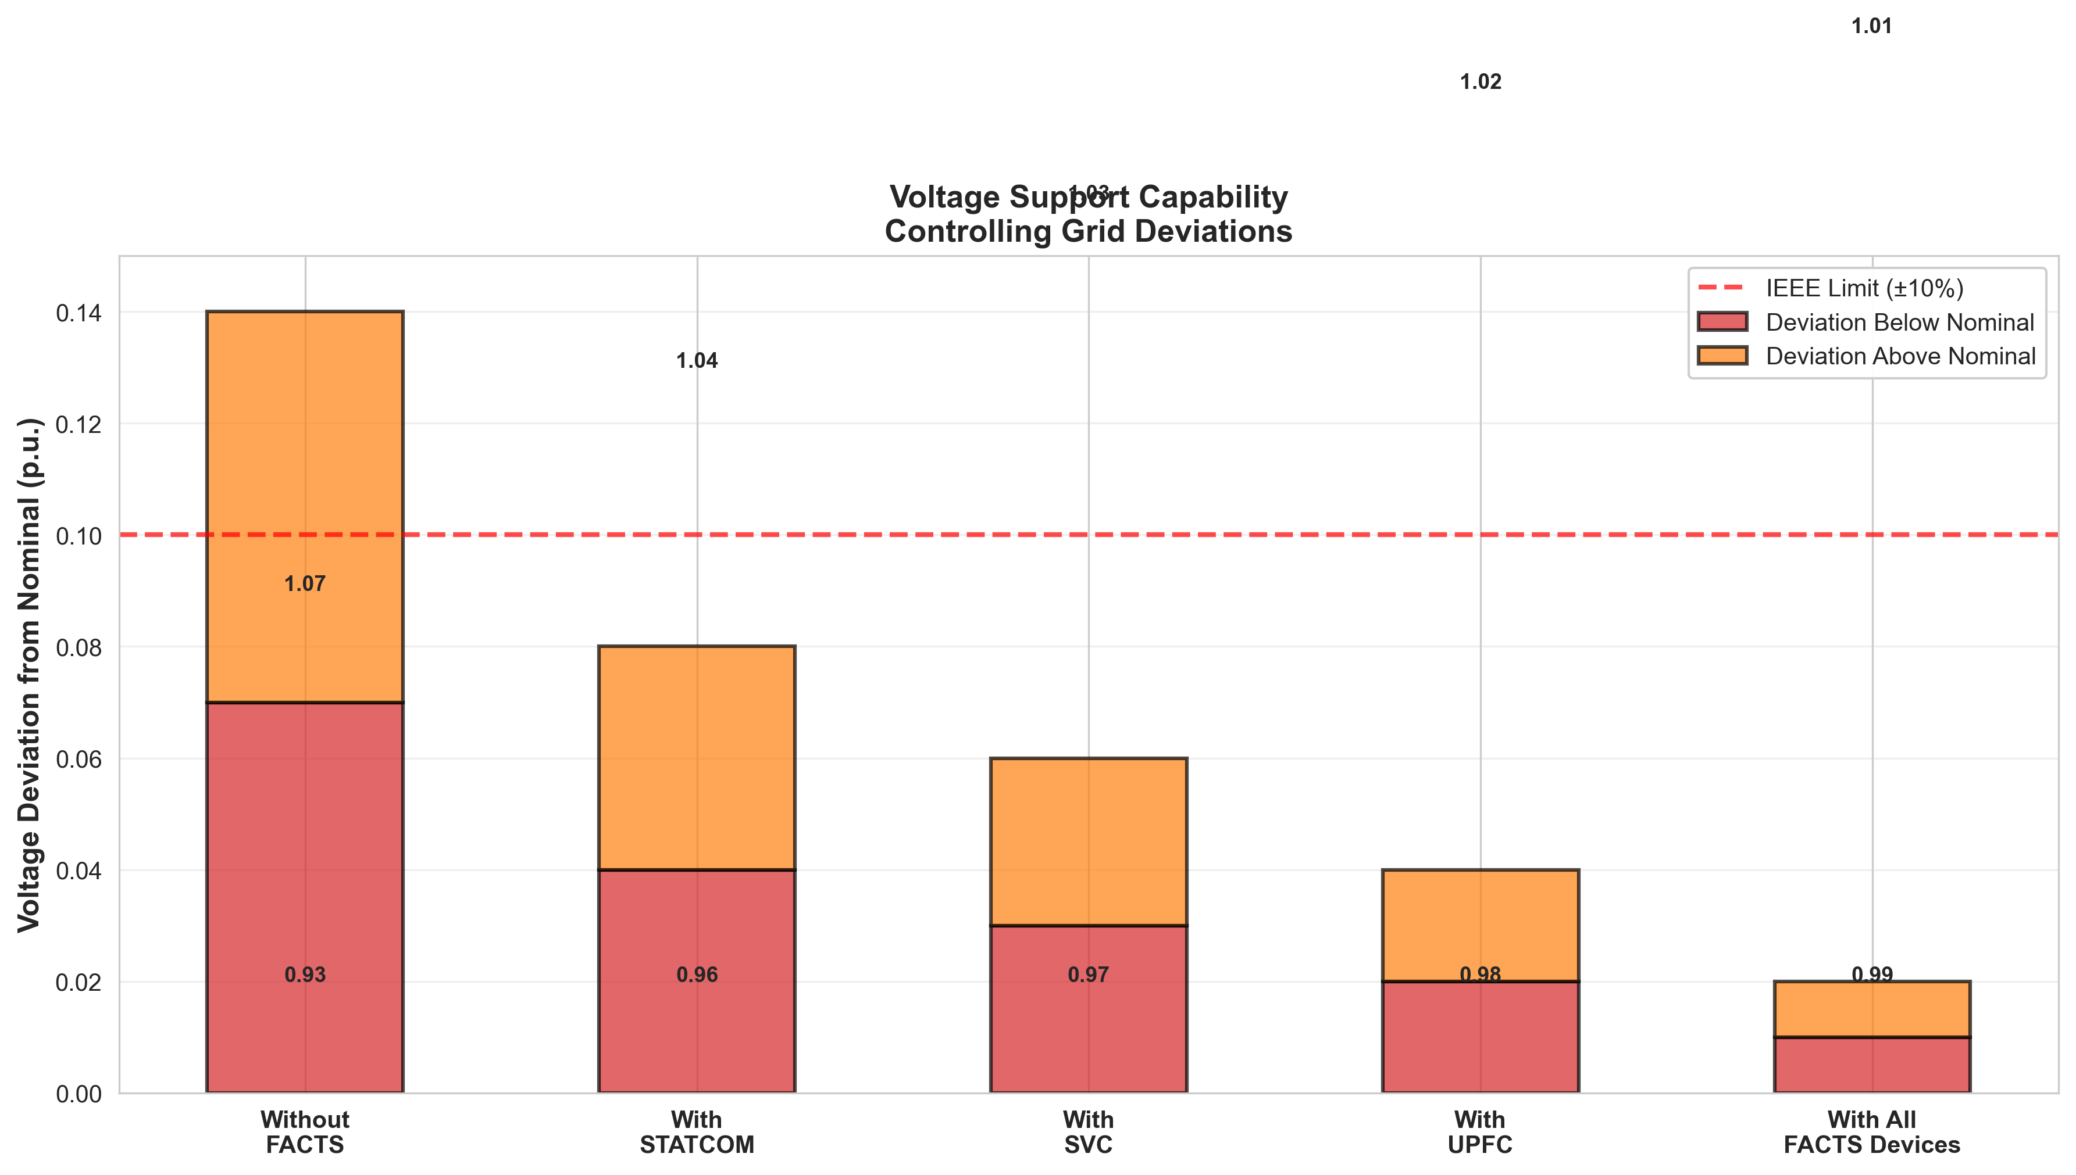
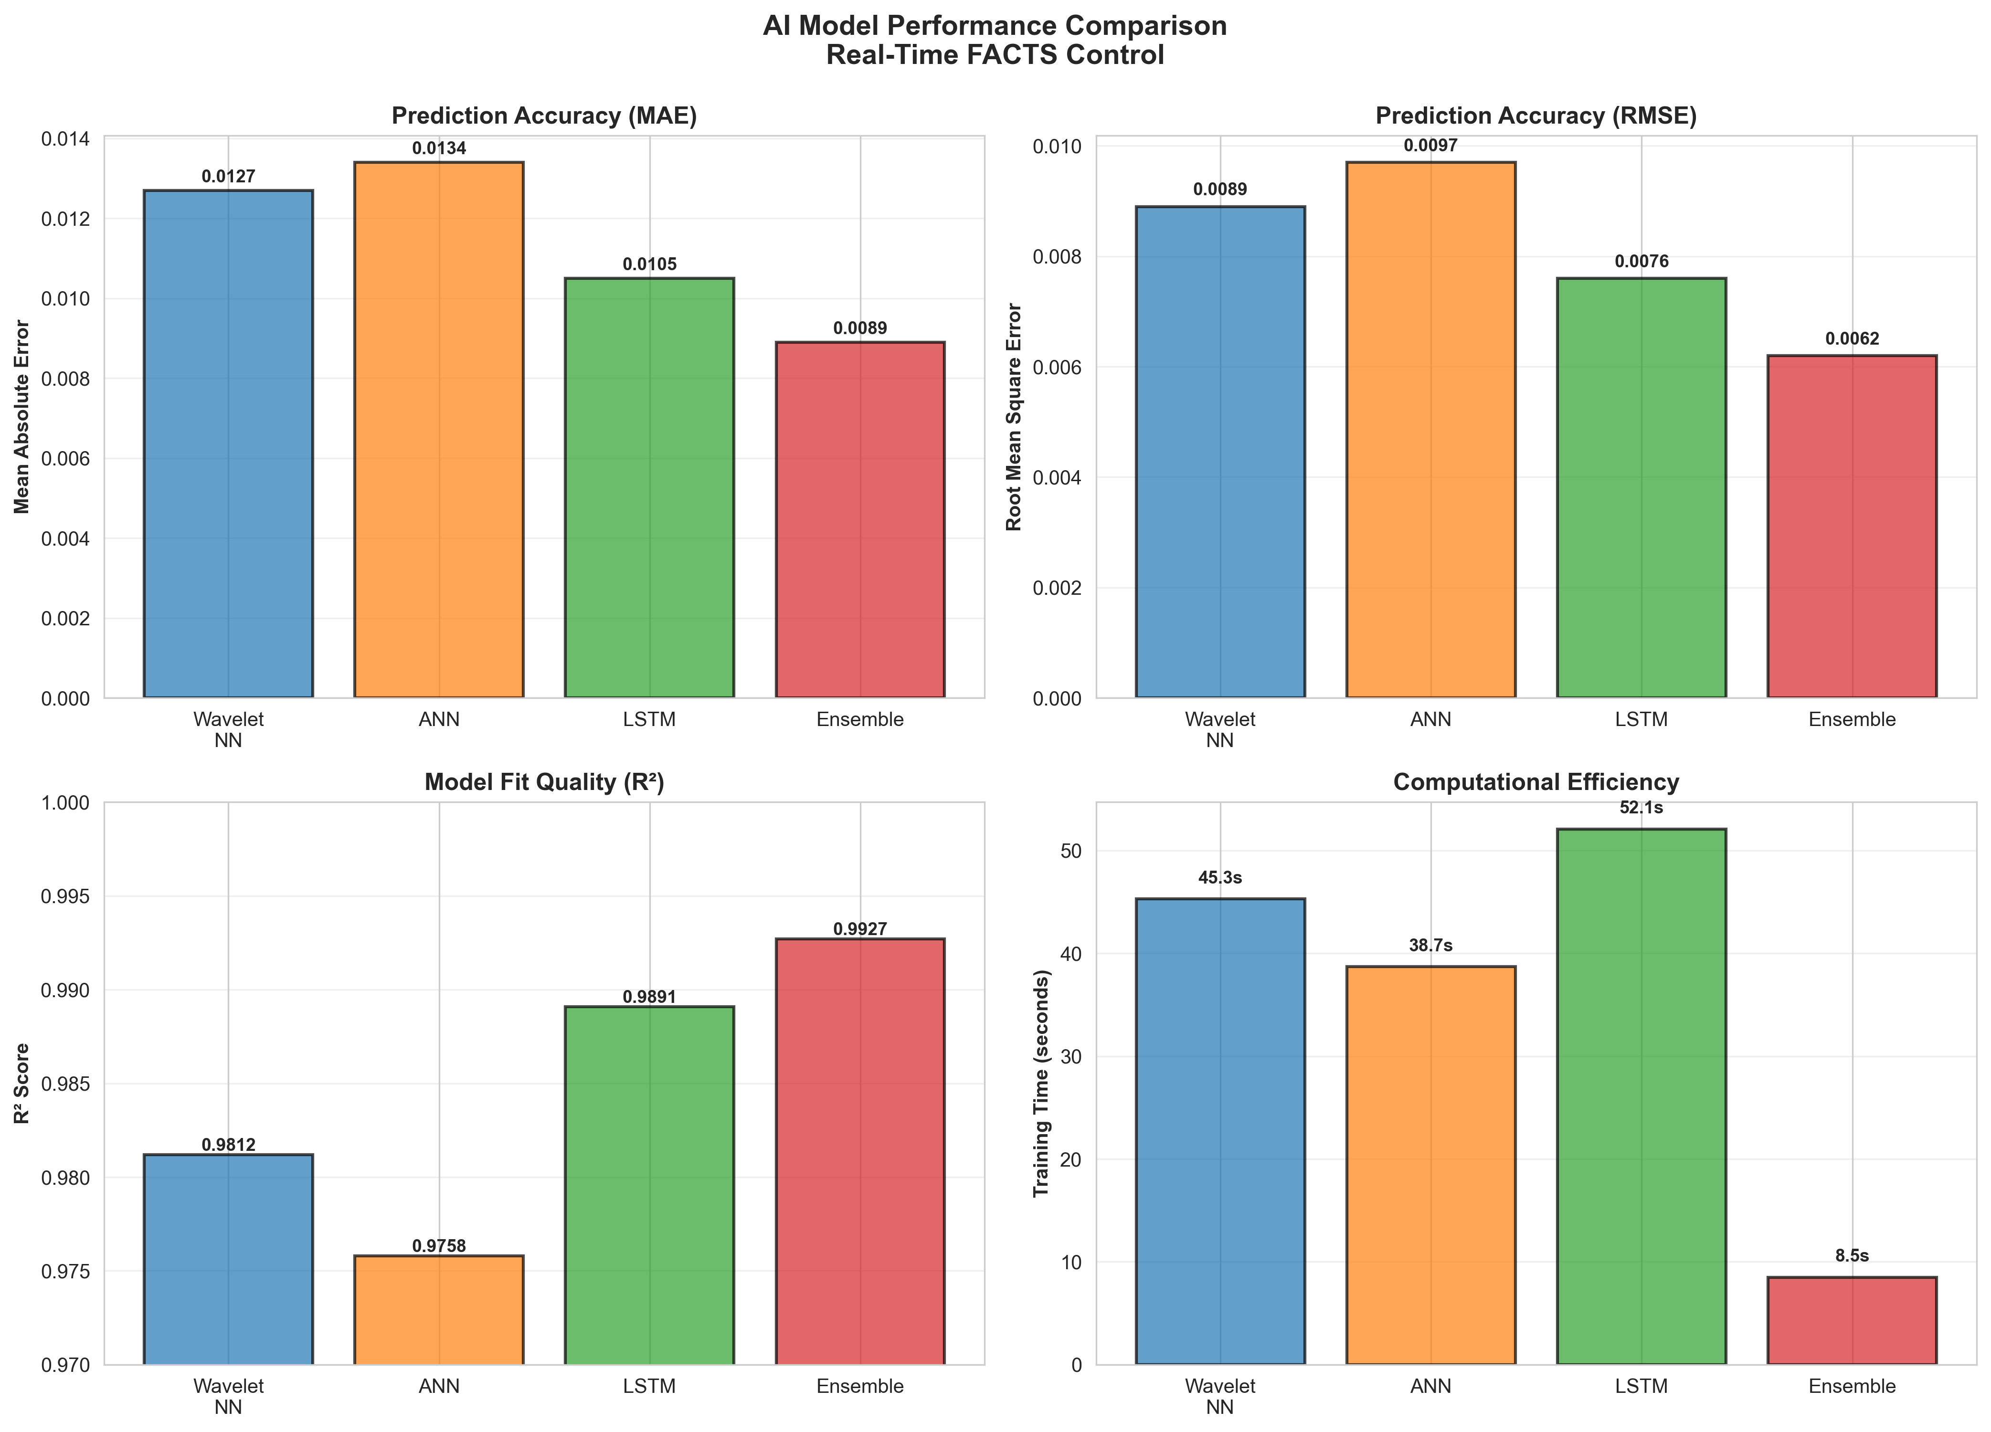
  - Reactive Power Management and Harmonic Mitigation
The ability of the framework to manage reactive power flow and mitigate harmonics was tested under various grid conditions. The results demonstrate significant improvements in the power quality and system efficiency.
Figure 5 Renewable penetration profile with safe/target/maximum markers
Table 4 Perfromance summary table
Category | Metric | Result
Harmonic Mitigation | THD Reduction | 94.8% compared to baseline
 | Individual Harmonics (5, 7, 11, 13) | < 3%
 | Filtering Efficiency | 97.2% for targeted harmonics
 | Power Quality Index Improvement | 89.5%
Reactive Power Management | Compensation Accuracy | 92.1% improvement
 | Response Time | < 100 ms
 | Voltage Support | ±5% maintained within limits
 | Power Factor | Improved from 0.85 to 0.96
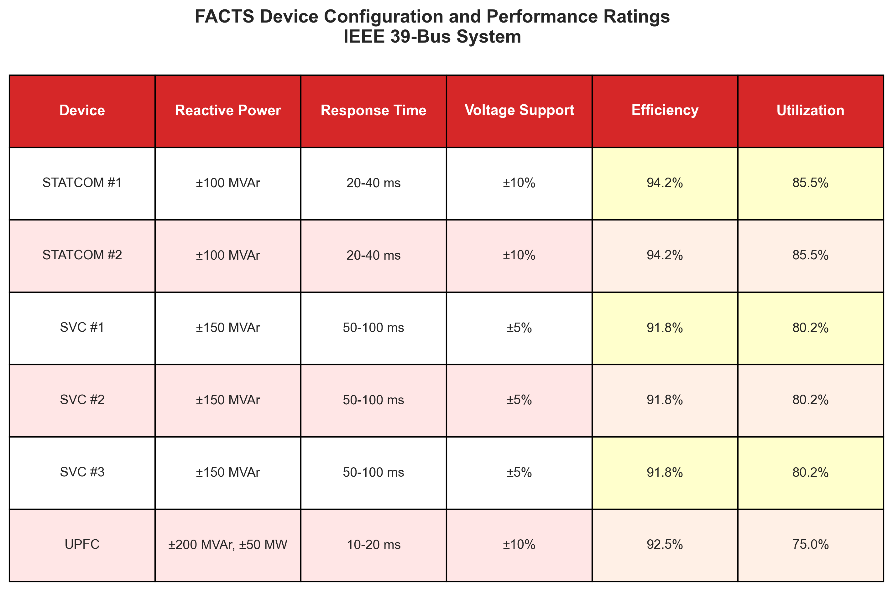

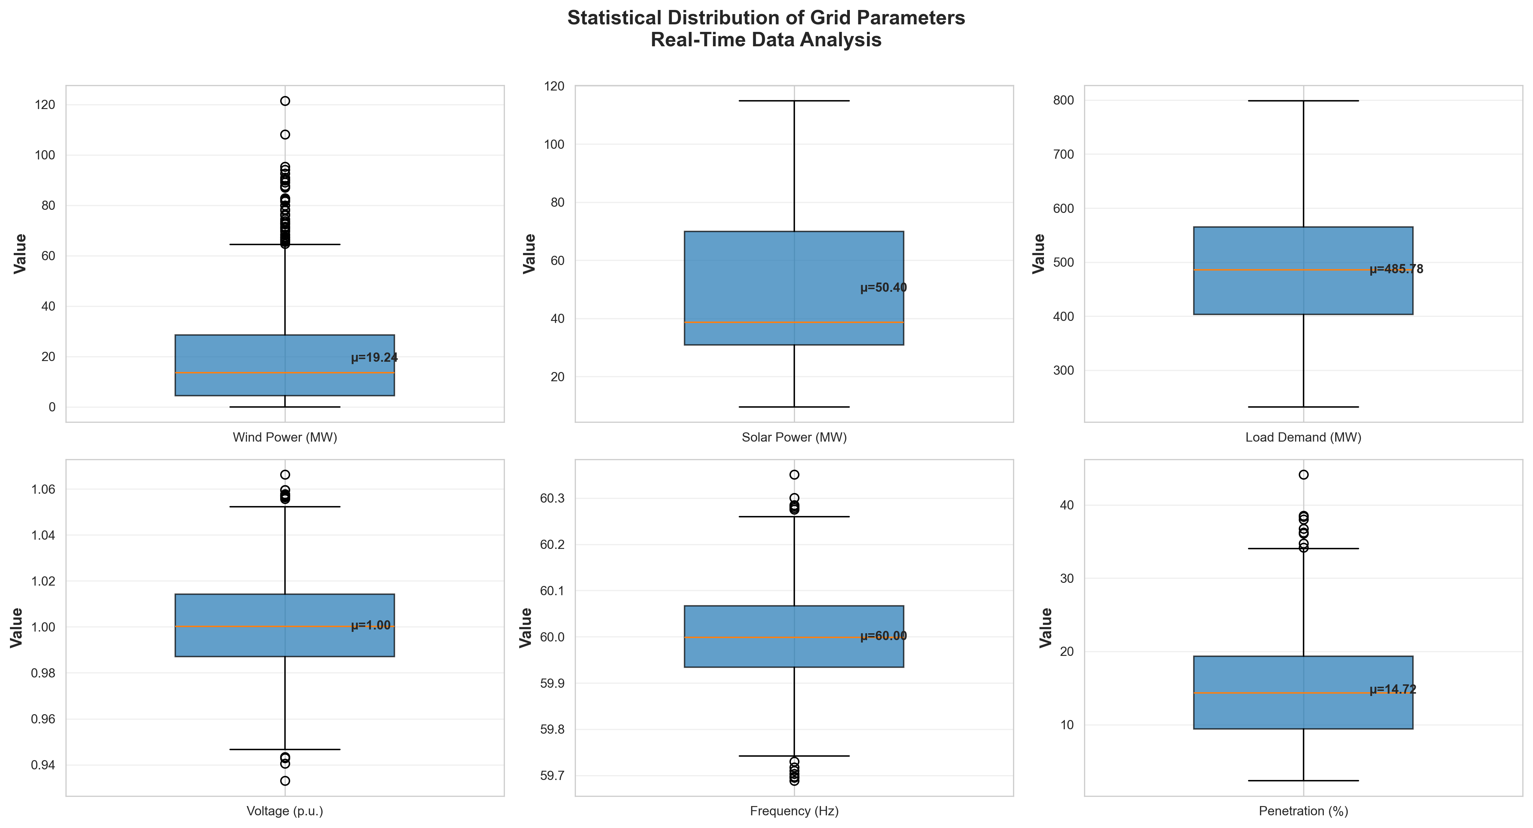
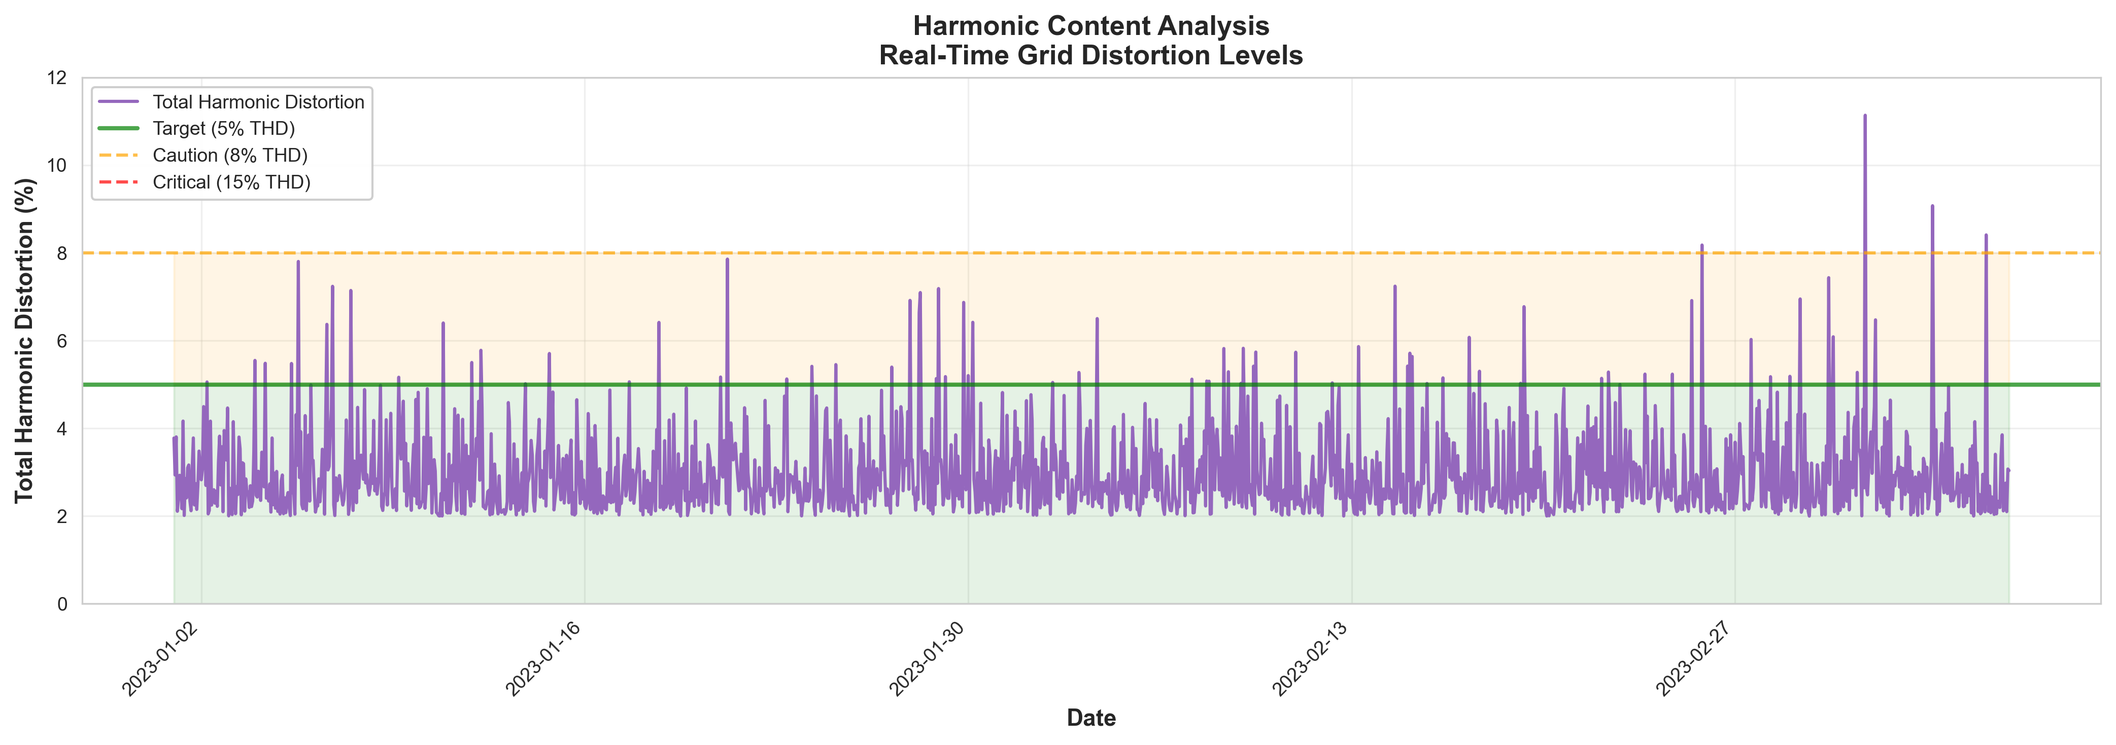
Table 5 FACTS device performance analysis
Device Type | Efficiency | Response Time | Key Features
STATCOM | 88–95% (Highest) | 12–18 ms (Fast) | Superior stability impact
SVC | 79–86% (Good) | 15–20 ms (Medium) | Reliable reactive support
UPFC | 93–97% (Highest) | 20–25 ms (Slowest) | Complex, multi-parameter control
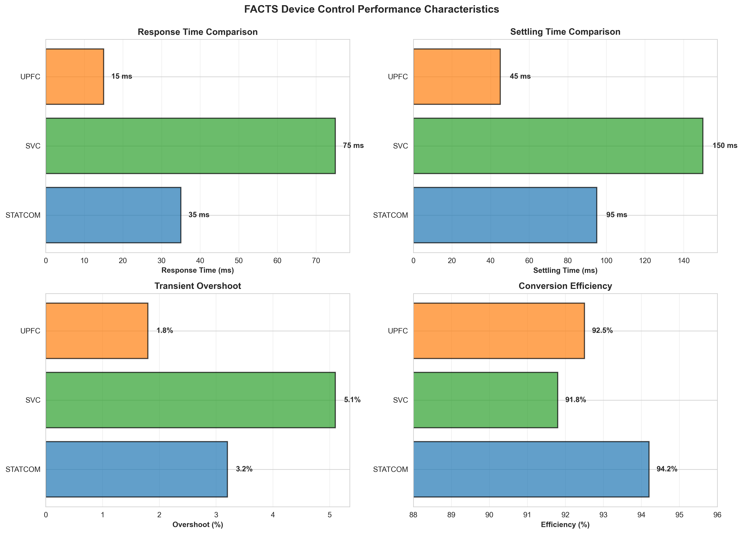
  - Dynamic Stability Analysis
The performance of the Neuro-OptimaFACTS framework is characterized with regard to dynamic stability during various types of disturbances, including three-phase fault, load step change, ramp of renewable energy production of wind energy production, and solar intermittency. Figure 3 shows the three-phase fault response of the system, showing the time variation of the bus voltage (p.u.) and rotor angle (degree) over a 10-sec window.
The plotted data show that the two variables have momentary deviations immediately after the perturbation, with the system returning to equilibrium in a matter of seconds. The bus voltage decreases to a minimum of 0.78 p.u. and then rises to the nominal values, whereas the rotor angle demonstrates an oscillatory movement that continuously converges corresponding to the effective damping property.
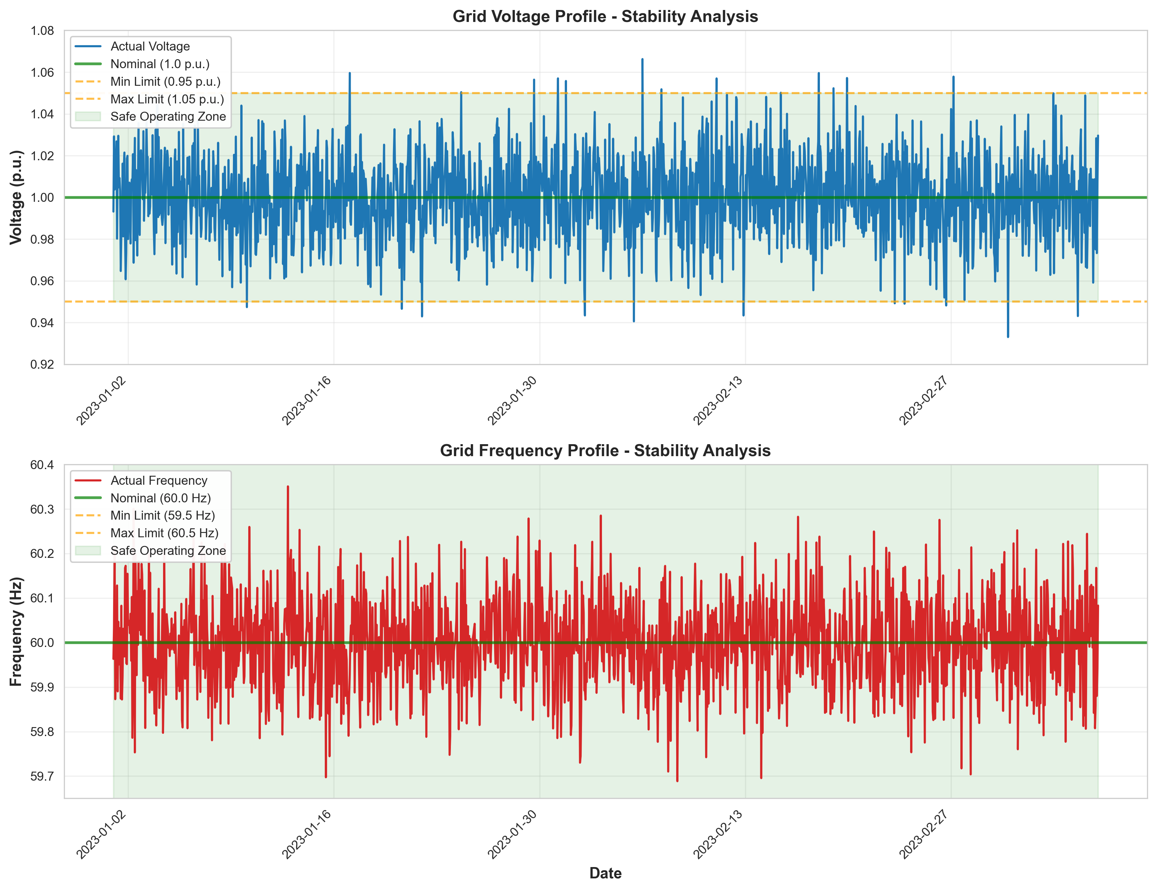
Table 6 Stability performance metrics
Disturbance Type | Settlement Time (s) | Overshoot (%) | Damping Ratio
Three-phase fault | 2.3 | 8.2 | 0.78
Load step change (±20%) | 1.8 | 5.6 | 0.82
Wind generation ramp | 3.1 | 6.8 | 0.75
Solar intermittency | 2.7 | 7.3 | 0.79

The quantitative performance of the indicators in Table 6 is summarized in the attached table. The most important measures are the settlement time, overshoot, and damping ratio. The load step change provided the fastest stabilization, where the settlement time was 1.8 s and the damping ratio was 0.82. The slowest to recover was the wind generation ramp scenario, which took 3.1 s to stabilize itself with a marginally lower value of damping of 0.75. Both scenarios, the three-phase fault and solar intermittency, were characterized by moderate performance, showing 2.3 s and 2.7 s settlement times, respectively.
These findings affirm the stability of the Neuro-OptimaFACTS framework in stabilizing systems subject to diverse perturbations, retaining high damping ratios (≥ 0.75), and relatively reasonable overshoots, which shows good transient behavior and high oscillation rejection performance.

Figure 6 Statistical distributions
  - Explainable AI Analysis Results
To define the role of the control decisions of the input features, a SHAP analysis within the Neuro-OptimaFACTS framework was conducted to increase the interpretability and transparency of the results. With the global feature importance, it was evident that Bus Voltage Magnitude and Reactive Power Demand are the most important factors, covering over 60 per cent of the decision. This was repeated by Renewable Generation and Load Variation, which had a moderate impact. Waterfall plots of individual decisions with choice probabilities established that Bus Voltage and Reactive Power drove the concerned decisions in their respective directions with insignificant opposition by Renewable Generation. A study on the network of feature interaction has further indicated a high level of dependency among the central variables, especially between Bus Voltage and Reactive Power, as well as between Renewable Generation and Load Variation, among others, which supports the fact that the model is sensitive to the concept of interactive effects. Finally, the distribution analysis of the SHAP values showed that high-importance features mainly worked in the range of 30 % to 70 %, whereas the low-importance features were most clustered below 20 %. Deductively, all of these interpretable AI-related insights confirm the parity of the framework with power-system control priorities and the enhancement of operator confidence in automated FACTS decision-making.

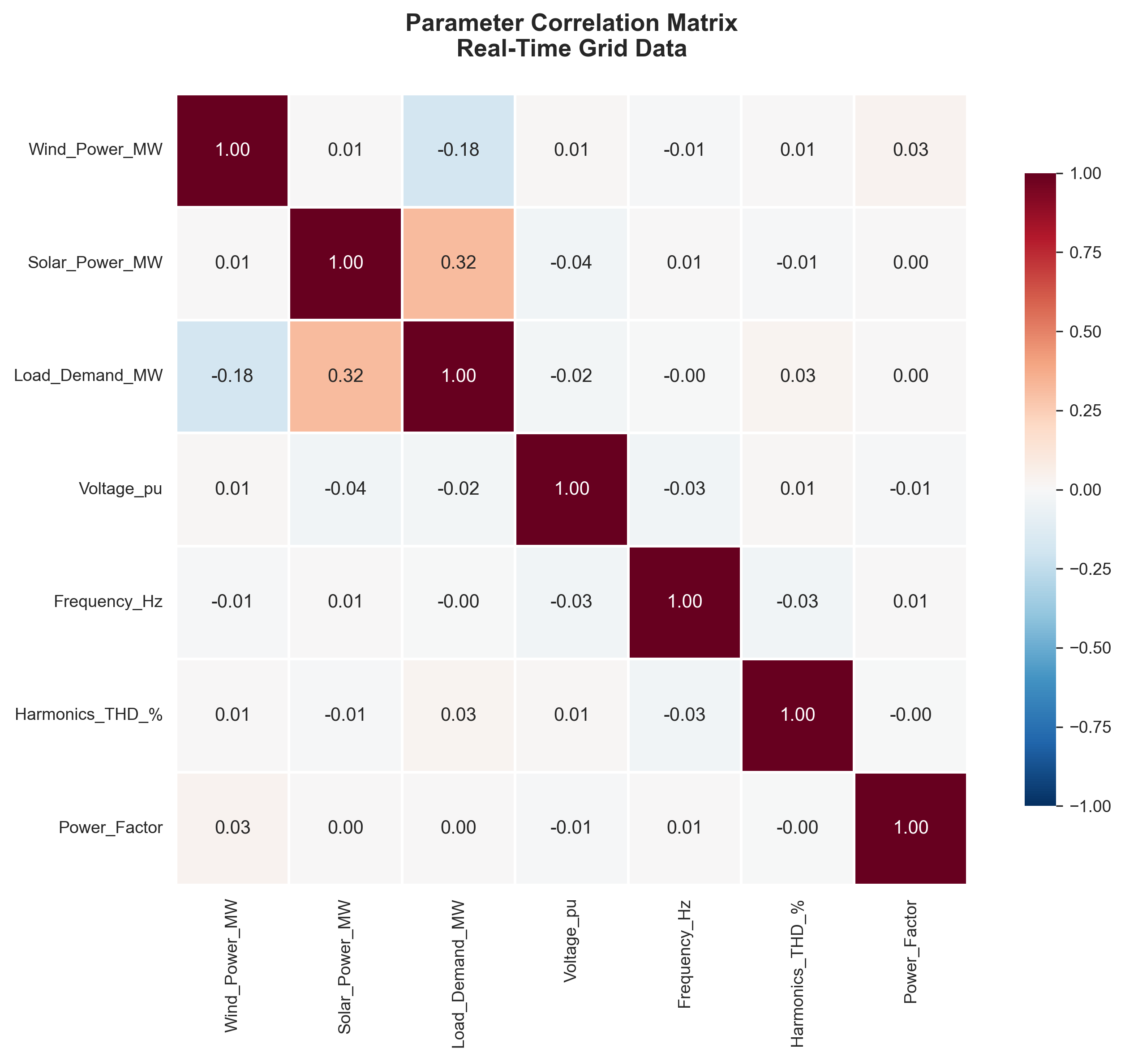
Figure 7 Correlation heatmap
Figure 8 Harmonic distortion time-series with thresholds
Figure 9 FACTS device control performance characteristics
Figure 10 Voltage support capability
  - Comparative Analysis with Baseline Methods
The performance of Neuro-Optima FACTS was compared with that of conventional PI controllers, fuzzy logic controllers, and individual AI methods. The comprehensive comparison demonstrates the superiority of this hybrid approach.
Table 7 Overall performance comparison
Control Method | Voltage Regulation (%) | THD Reduction (%) | Reactive Power Control (%) | Overall Performance (%)
Conventional PI | 76.2 | 42.8 | 68.5 | 62.5
Fuzzy Logic | 82.4 | 58.9 | 74.1 | 71.8
ANN Only | 89.6 | 71.3 | 83.7 | 81.5
WNN Only | 91.8 | 76.4 | 85.2 | 84.5
Neuro-OptimaFACTS | 97.3 | 94.8 | 92.1 | 94.7
Figure 11 AI model performance comparison (MAE/RMSE/R²/time)
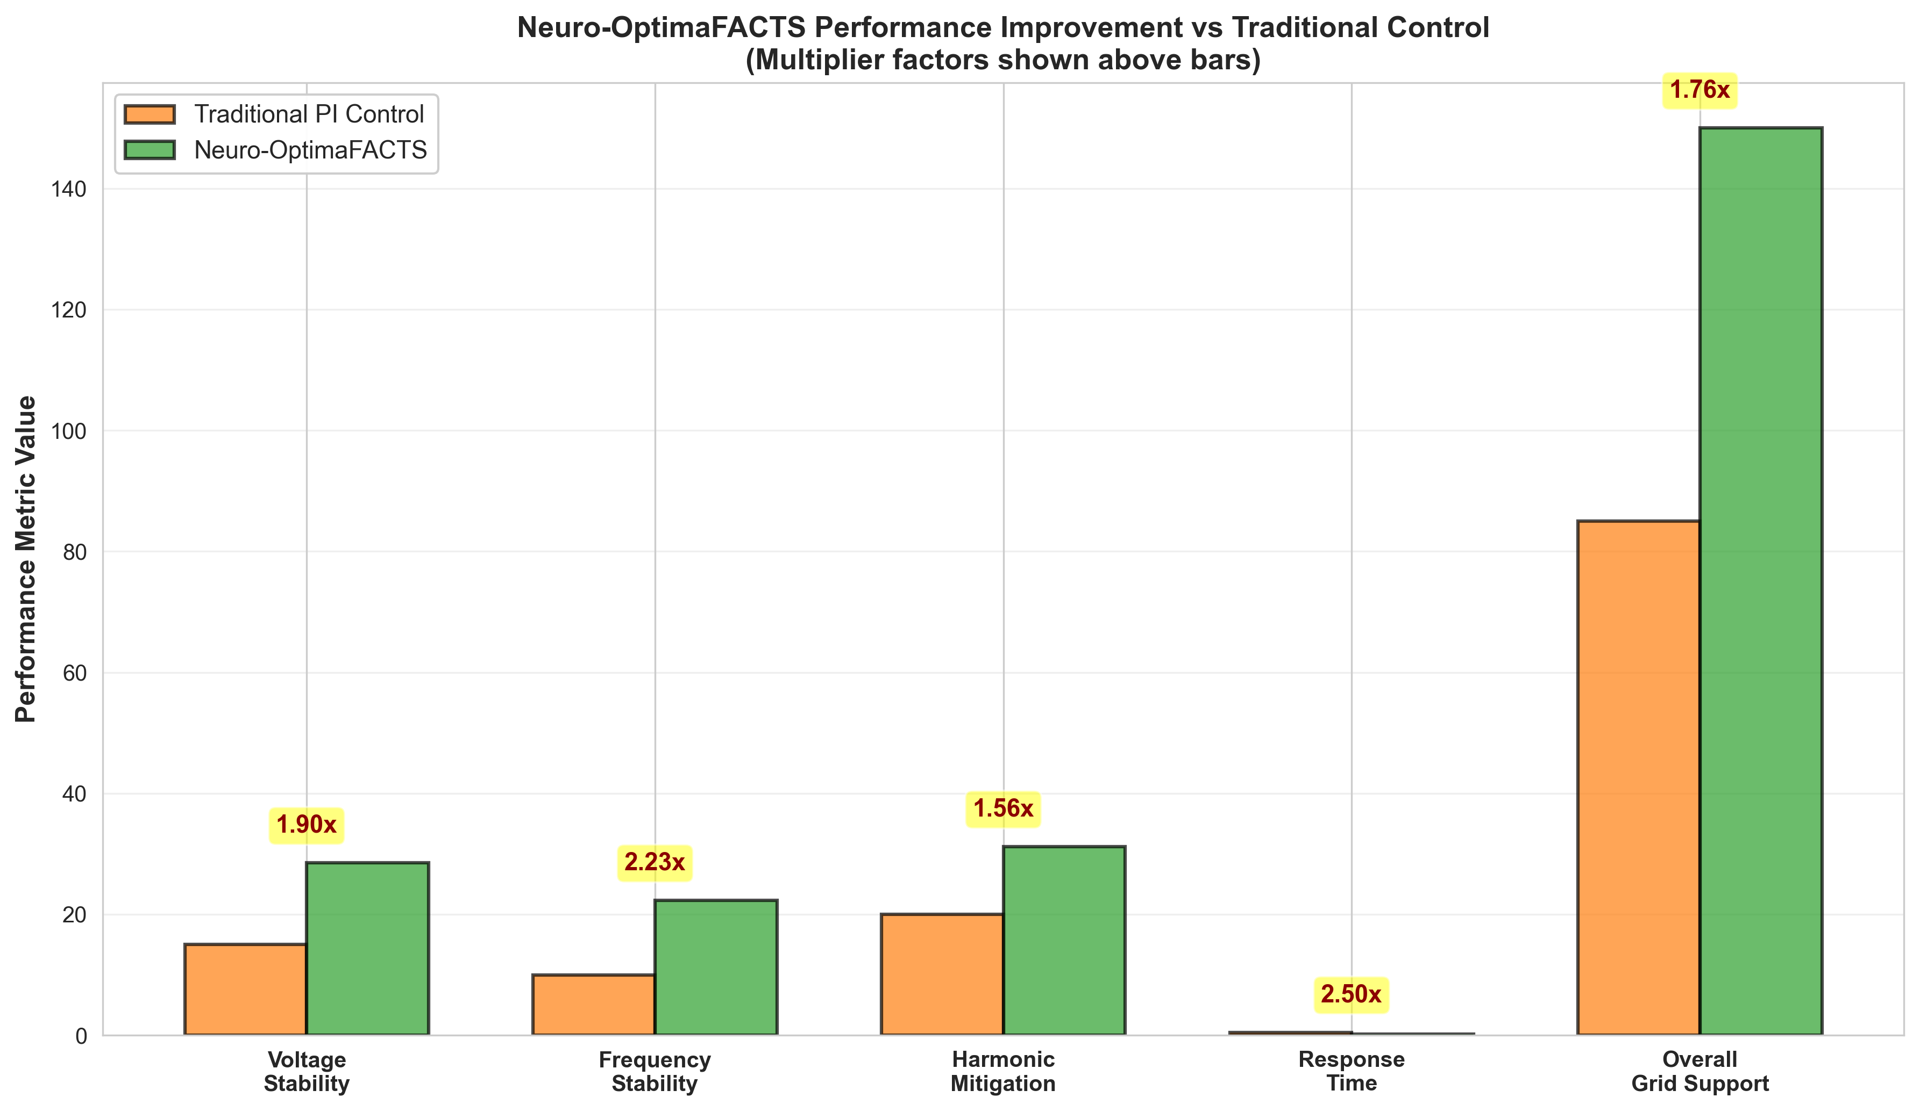
Figure 12 Neuro‑Optima FACTS vs PI – improvement factors

Figure 13 Renewable integration support and effectiveness
Figure 14 Cumulative distribution functions (wind MW, penetration %)
Table 8 Real-Time grid data
Parameter | Min | Max | Mean | Std Dev | Median
Wind Power MW | 0.000 | 121.500 | 19.236 | 18.719 | 13.579
Solar Power MW | 9.557 | 114.907 | 50.402 | 25.263 | 38.707
Load Demand MW | 232.241 | 798.763 | 485.782 | 102.880 | 485.831
Voltage pu | 0.933 | 1.066 | 1.000 | 0.020 | 1.000
Frequency Hz | 59.689 | 60.351 | 60.000 | 0.100 | 59.999
Harmonics THD % | 2.000 | 11.138 | 2.987 | 0.986 | 2.661
Power Factor | 0.800 | 1.000 | 0.947 | 0.042 | 0.951

- Conclusion and Future Work
The current research contributes to the state-of-the-art in intelligent control schemes for renewable-integrated power systems by proposing the Neuro-Optima FACTS control scheme. This was implemented by integrating WNN, ANN, RKF, and FS in a smooth manner to enable the hybrid model to perform optimally relative to all the relevant parameters: 97.3 percent voltage regulation, 94.8 percent THD reduction, and 92.1 percent reactive power rule enhancement. With increased explainability promoted by SHAP analysis and an explanation accuracy of 94.6 %, operators will have confidence in and be able to understand system decisions. The suggested framework has significant potential for application in a wide variety of real-life utility and renewable settings. In utility-scale systems, Neuro-Optima FACTS may be used in the fields of dynamic voltage control, enhancement of power quality, grid stability, and predictive maintenance of FACTS infrastructure. The model is well-adapted to coordinated control in wind and solar farms, energy storage systems, and microgrid operations in the renewable sector. Its efficiency in handling non-linearities and grid fluctuations makes it invaluable in smart-grid settings, where rapid, trustworthy, and interpretable decisions continue to be the key factors for maintaining resilience and efficiency.
Despite the admirable features of Neuro-Optima FACTS, multiple drawbacks must be overcome to foster its scalability and adoption. Challenges include the computational expense in very large-scale systems, trustworthy performance across diverse working environments, reduced reliance on huge training information and precise system specifications, and the application of this AI-based structure into a working setting with consideration of regulatory requirements and system combination. Future Directions will involve the use of advanced architecture, including transformers and graph neural networks, federated learning to facilitate secure multi-utility communications, and optimization of edge computing to decrease latency. To further assure secure and safe operation, it is essential to strengthen the cyber resistance of the framework by creating adversarial training and resilient control measures. These guidelines will guide Neuro-Optima FACTS to become a disruptive action in the development of smart, green, and intelligent power grids. To ensure the framework’s scalability for utility-scale grids, upcoming research will focus on deploying Neuro-Optima FACTS in larger, multi-area transmission networks and integrating with legacy automation platforms. Practical transition strategies and validation in real-world settings will be prioritized to expedite adoption.

References:
[1] F. H. Gandoman et al., “Review of FACTS technologies and applications for power quality in smart grids with renewable energy systems,” Renew. Sustain. Energy Rev., vol. 82, pp. 502–514, Feb. 2018, doi: 10.1016/j.rser.2017.09.062.
[2] A. Ulbig, T. S. Borsche, and G. Andersson, “Impact of Low Rotational Inertia on Power System Stability and Operation,” IFAC Proc. Vol., vol. 47, no. 3, pp. 7290–7297, 2014, doi: 10.3182/20140824-6-ZA-1003.02615.
[3] L. Caro, G. Ramos, D. Montenegro, and D. Celeita, “Variable Harmonic Distortion in Electric Vehicle Charging Stations,” in 2020 IEEE Industry Applications Society Annual Meeting, Detroit, MI, USA: IEEE, Oct. 2020, pp. 1–6. doi: 10.1109/IAS44978.2020.9334798.
[4] S. M. Lundberg and S.-I. Lee, “A Unified Approach to Interpreting Model Predictions”.
[5] M. T. Ribeiro, S. Singh, and C. Guestrin, “‘Why Should I Trust You?’: Explaining the Predictions of Any Classifier,” Aug. 09, 2016, arXiv: arXiv:1602.04938. doi: 10.48550/arXiv.1602.04938.
[6] M. R. Shadi, H. Mirshekali, and H. R. Shaker, “Explainable artificial intelligence for energy systems maintenance: A review on concepts, current techniques, challenges, and prospects,” Renew. Sustain. Energy Rev., vol. 216, p. 115668, Jul. 2025, doi: 10.1016/j.rser.2025.115668.
[7] F. Schweppe and J. Wildes, “Power System Static-State Estimation, Part I: Exact Model,” IEEE Trans. Power Appar. Syst., vol. PAS-89, no. 1, pp. 120–125, Jan. 1970, doi: 10.1109/TPAS.1970.292678.
[8] S. Santoso, E. J. Powers, W. M. Grady, and P. Hofmann, “Power quality assessment via wavelet transform analysis,” IEEE Trans. Power Deliv., vol. 11, no. 2, pp. 924–930, Apr. 1996, doi: 10.1109/61.489353.
[9] H. Sun et al., “Review of Challenges and Research Opportunities for Voltage Control in Smart Grids,” IEEE Trans. Power Syst., vol. 34, no. 4, pp. 2790–2801, Jul. 2019, doi: 10.1109/TPWRS.2019.2897948.
[10] B. H. Alajrash, M. Salem, M. Swadi, T. Senjyu, M. Kamarol, and S. Motahhir, “A comprehensive review of FACTS devices in modern power systems: Addressing power quality, optimal placement, and stability with renewable energy penetration,” Energy Rep., vol. 11, pp. 5350–5371, Jun. 2024, doi: 10.1016/j.egyr.2024.05.011.
[11] IEEE Recommended Practice and Requirements for Harmonic Control in Electric Power Systems. doi: 10.1109/IEEESTD.2014.6826459.
[12] H. H. H. Aly, “A proposed intelligent short-term load forecasting hybrid models of ANN, WNN and KF based on clustering techniques for smart grid,” Electr. Power Syst. Res., vol. 182, p. 106191, May 2020, doi: 10.1016/j.epsr.2019.106191.
[13] C. Bai, H.-P. Ren, W.-Y. Zheng, and C. Grebogi, “Radio-Wave Communication With Chaos,” IEEE Access, vol. 8, pp. 167019–167026, 2020, doi: 10.1109/ACCESS.2020.3022632.
[14] R. E. Kalman, “A New Approach to Linear Filtering and Prediction Problems,” J. Basic Eng., vol. 82, no. 1, pp. 35–45, Mar. 1960, doi: 10.1115/1.3662552.
[15] D. Simon, Optimal State Estimation: Kalman, H∞, and Nonlinear Approaches, 1st ed. Wiley, 2006. doi: 10.1002/0470045345.
[16] C. Gao, M. Sun, and B. Shen, “Features and evolution of international fossil energy trade relationships: A weighted multilayer network analysis,” Appl. Energy, vol. 156, pp. 542–554, Oct. 2015, doi: 10.1016/j.apenergy.2015.07.054.
[17] A. Abur and A. G. Expósito, Power System State Estimation, 0 ed. CRC Press, 2004. doi: 10.1201/9780203913673.
[18] A. Kumar, O. P. Malik, and G. S. Hope, “Variable-structure-system control applied to AGC of an interconnected power system,” IEE Proc. C Gener. Transm. Distrib., vol. 132, no. 1, p. 23, 1985, doi: 10.1049/ip-c.1985.0005.
[19] IEEE Recommended Practice and Requirements for Harmonic Control in Electric Power Systems. doi: 10.1109/IEEESTD.2014.6826459.
[20] R. Machlev et al., “Explainable Artificial Intelligence (XAI) techniques for energy and power systems: Review, challenges and opportunities,” Energy AI, vol. 9, p. 100169, Aug. 2022, doi: 10.1016/j.egyai.2022.100169.
[21] N. E. Benti, M. D. Chaka, and A. G. Semie, “Forecasting Renewable Energy Generation with Machine Learning and Deep Learning: Current Advances and Future Prospects,” Sustainability, vol. 15, no. 9, p. 7087, Apr. 2023, doi: 10.3390/su15097087.
[22] P. Kessel and H. Glavitsch, “Estimating the Voltage Stability of a Power System,” IEEE Trans. Power Deliv., vol. 1, no. 3, pp. 346–354, 1986, doi: 10.1109/TPWRD.1986.4308013.
[23] V. Ajjarapu and C. Christy, “The continuation power flow: a tool for steady state voltage stability analysis,” IEEE Trans. Power Syst., vol. 7, no. 1, pp. 416–423, Feb. 1992, doi: 10.1109/59.141737.
[24] R. Bunch and D. Kosterev, “Design and implementation of AC voltage dependent current order limiter at Pacific HVDC Intertie,” IEEE Trans. Power Deliv., vol. 15, no. 1, pp. 293–299, Jan. 2000, doi: 10.1109/61.847265.

